Lacson, Kristoffer C.

WD-201

1. 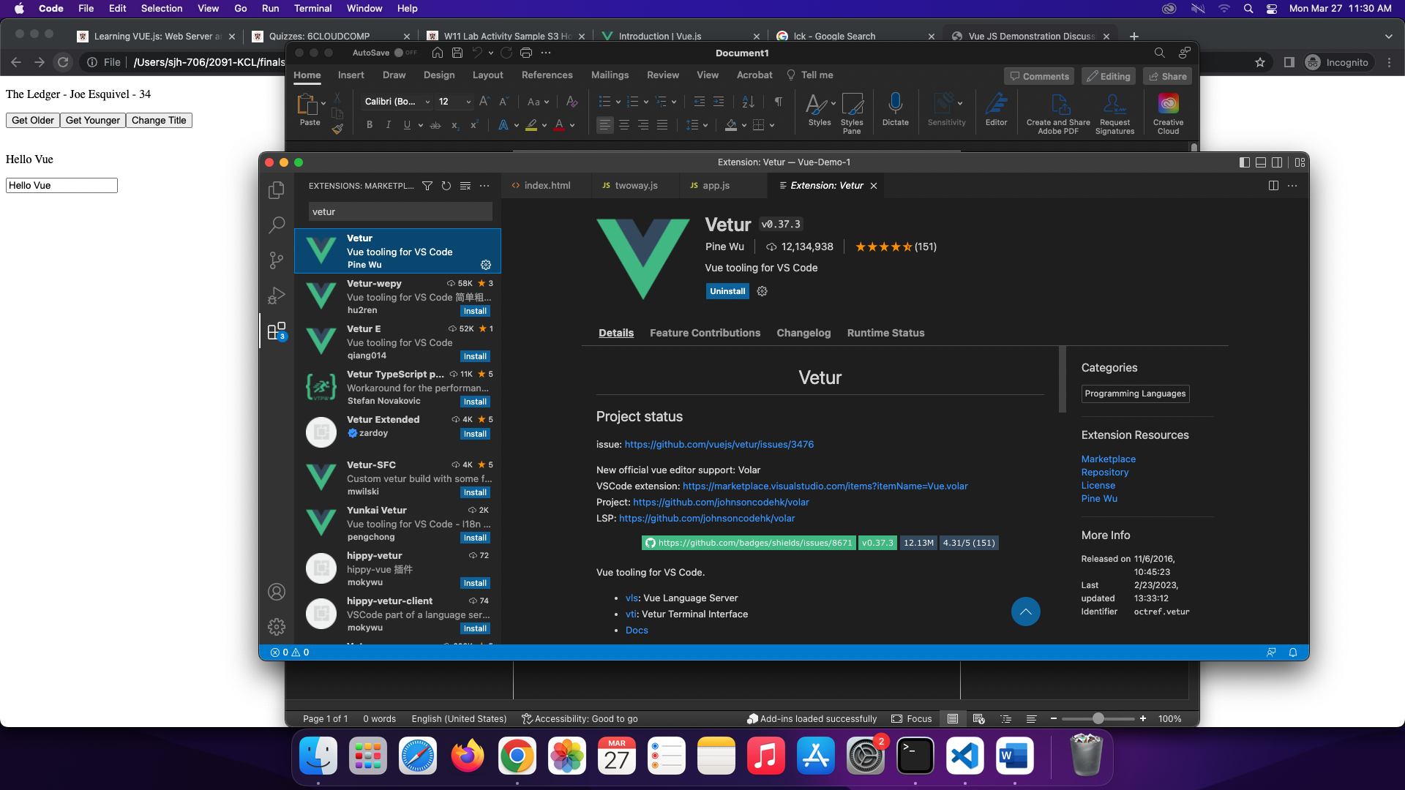Successful installation of VS Code (or on other code editors) Extensions.
2. 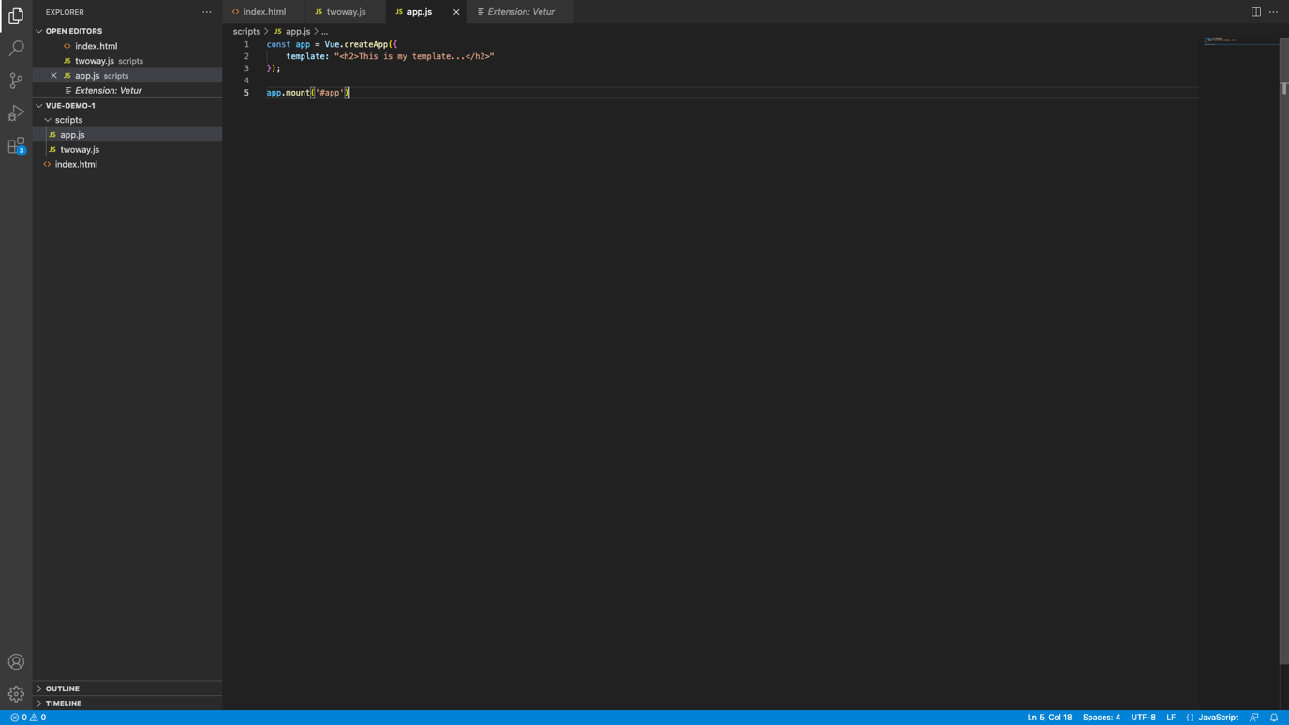Output of Figure 7

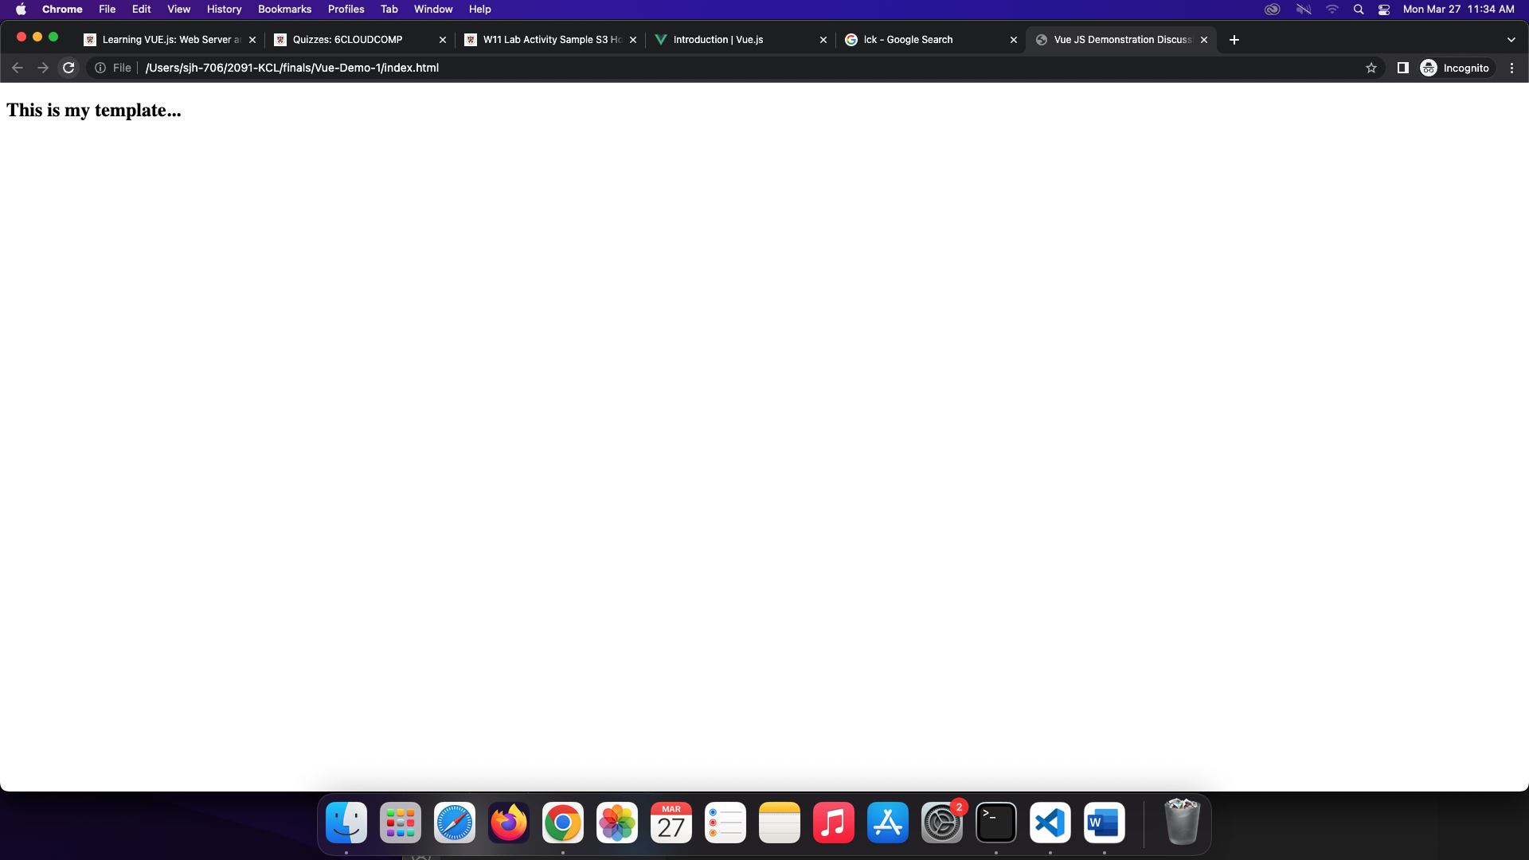

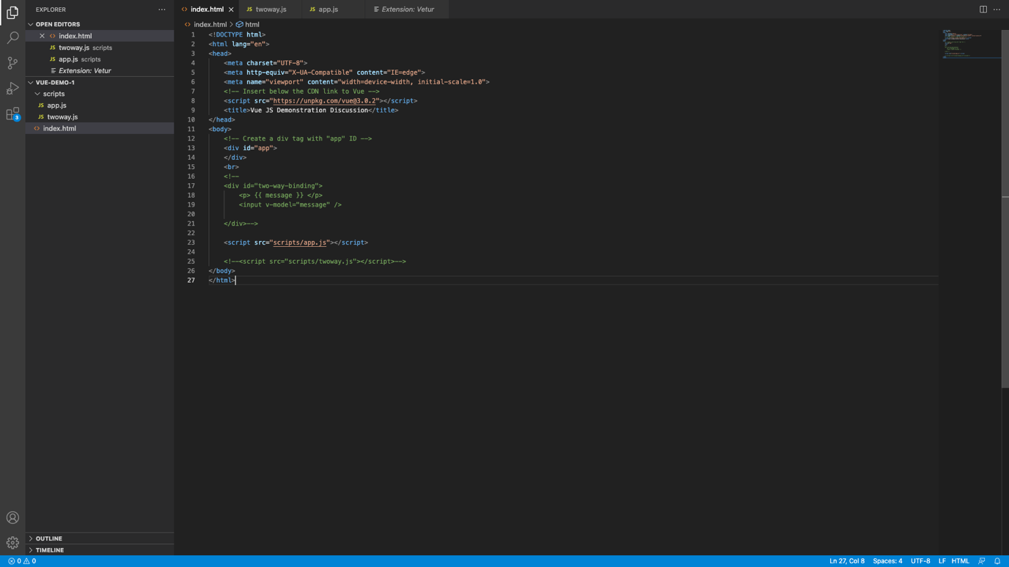

1. Output of Figure 9, Using Directives

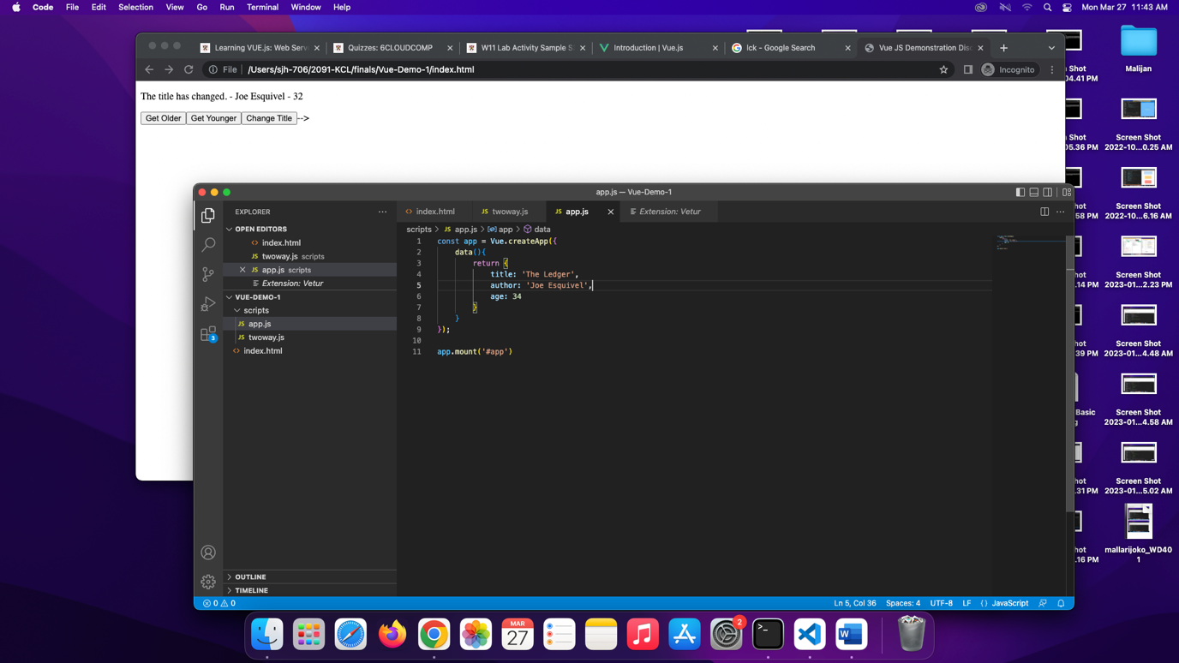

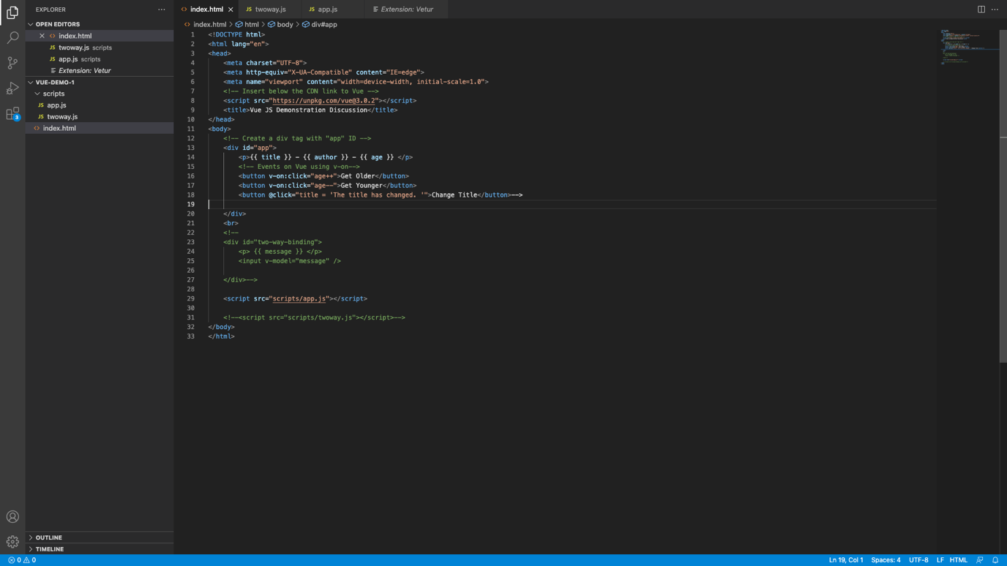

1. Output of Figure 12, implementing two-way data binding

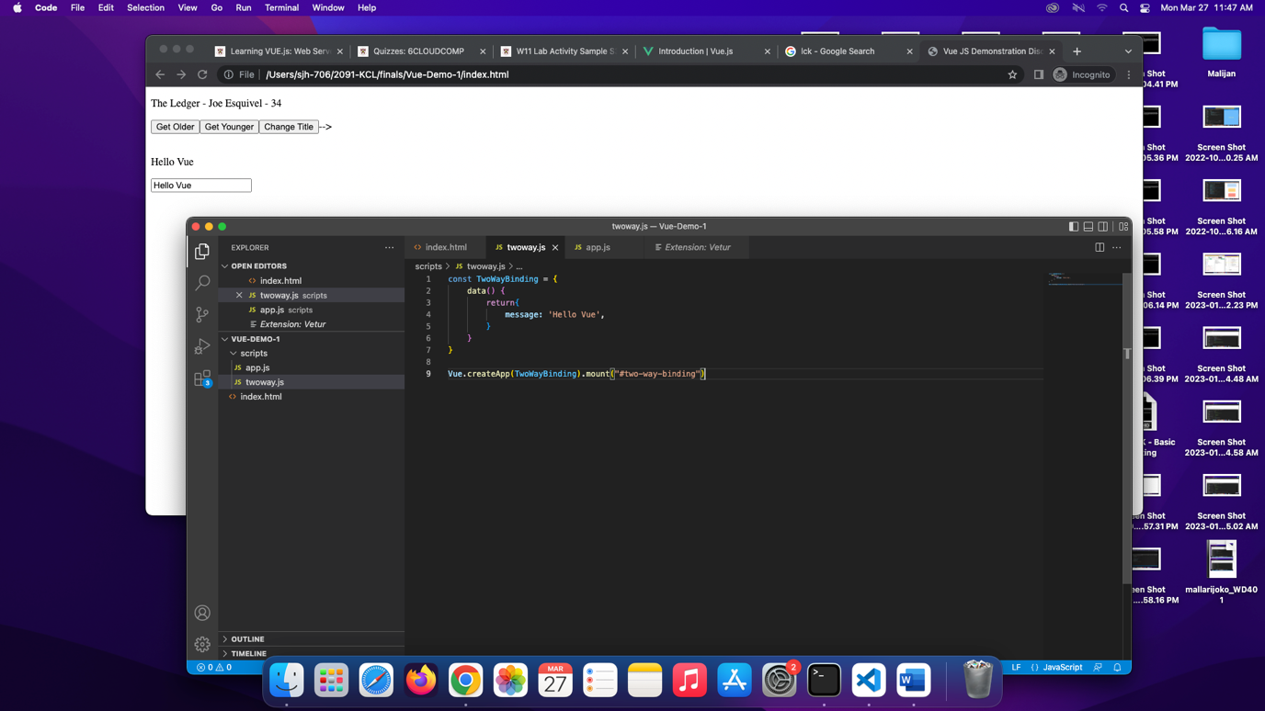

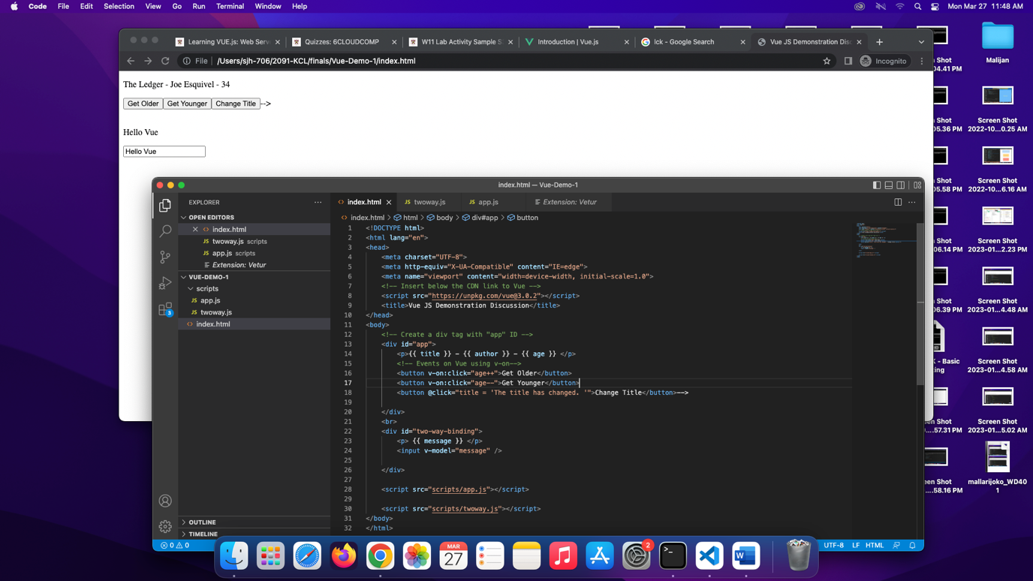

1. Output of Figure 14, using v-if statement

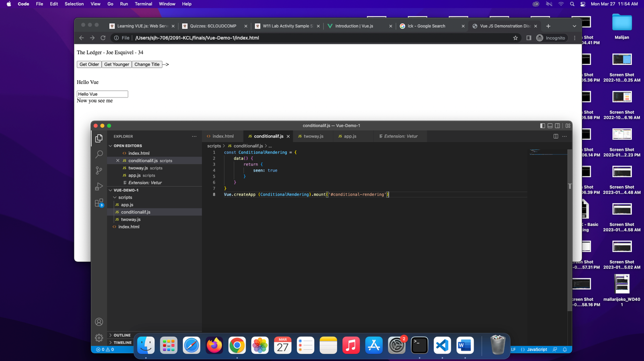

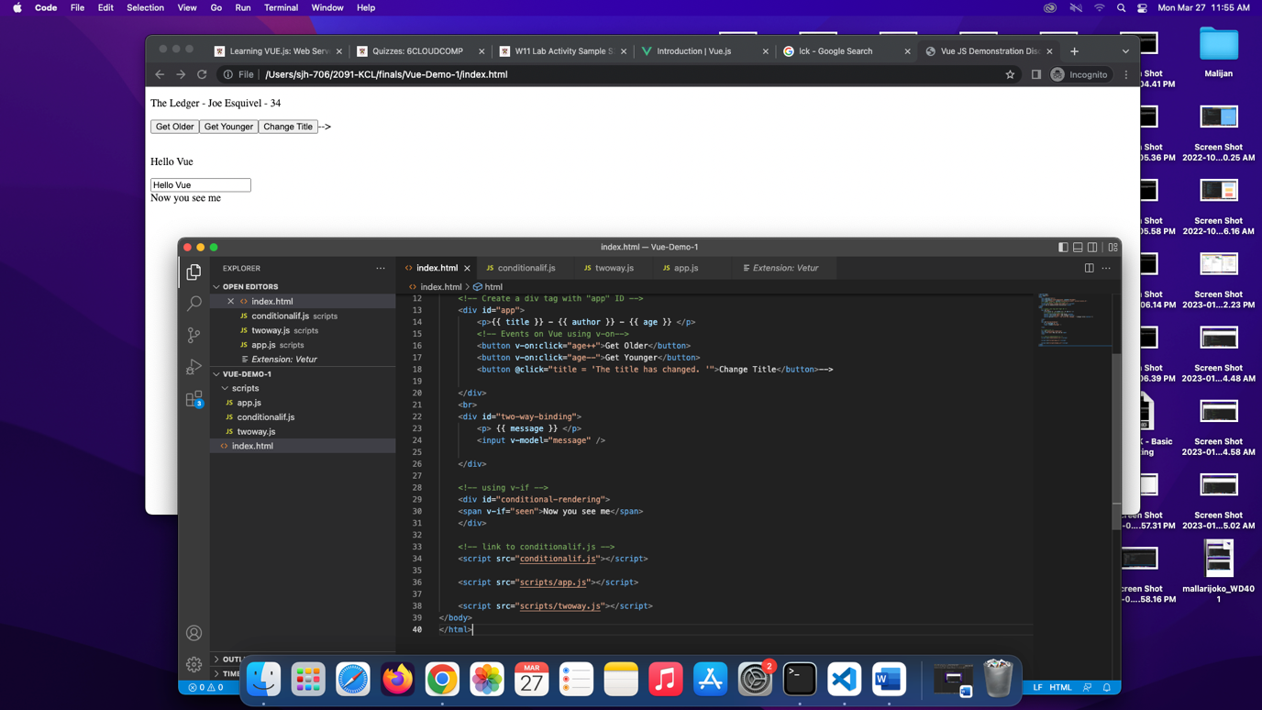

1. Output of Figure 16, using v-if statement and v-else statements.

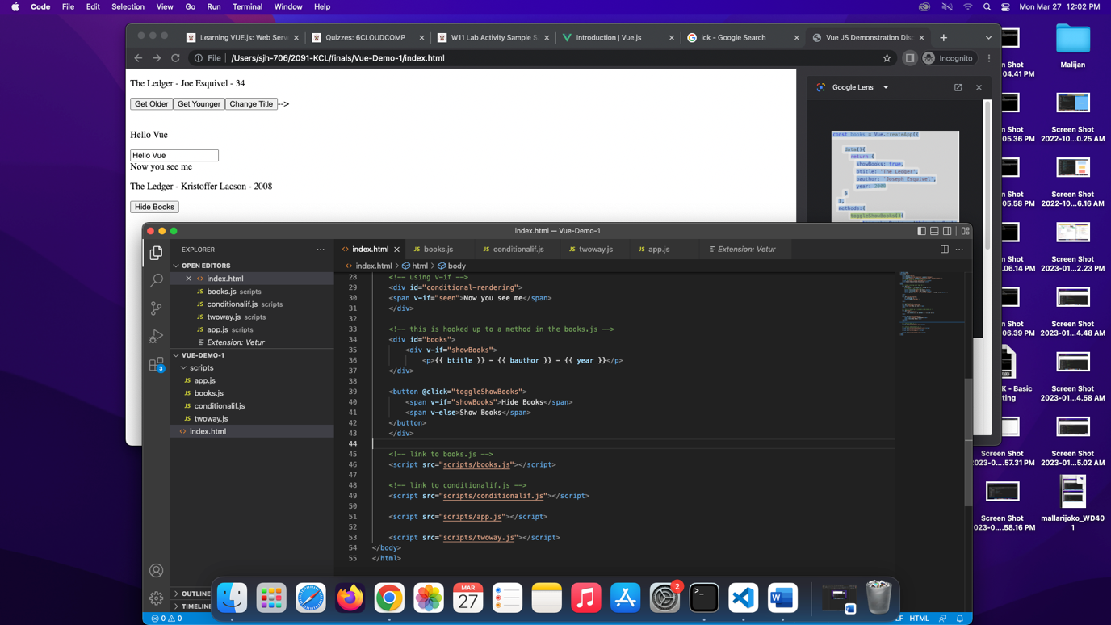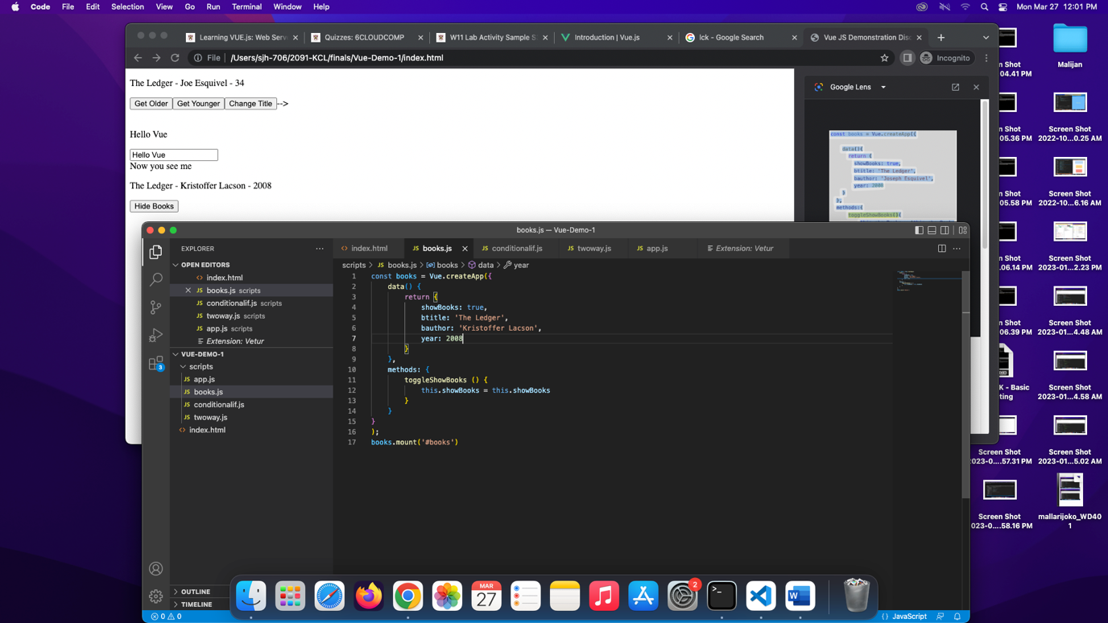

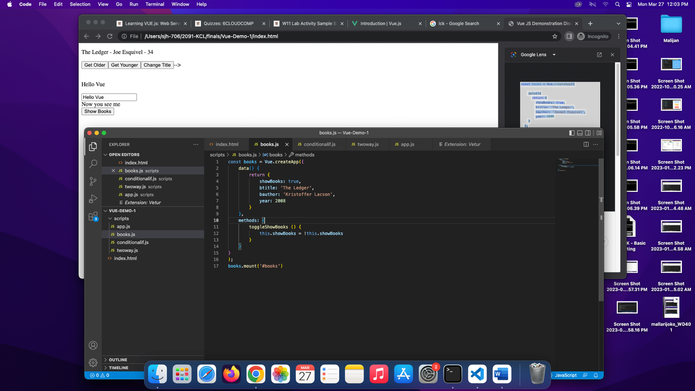

1. Output of Figure 19, demonstrating v-for.

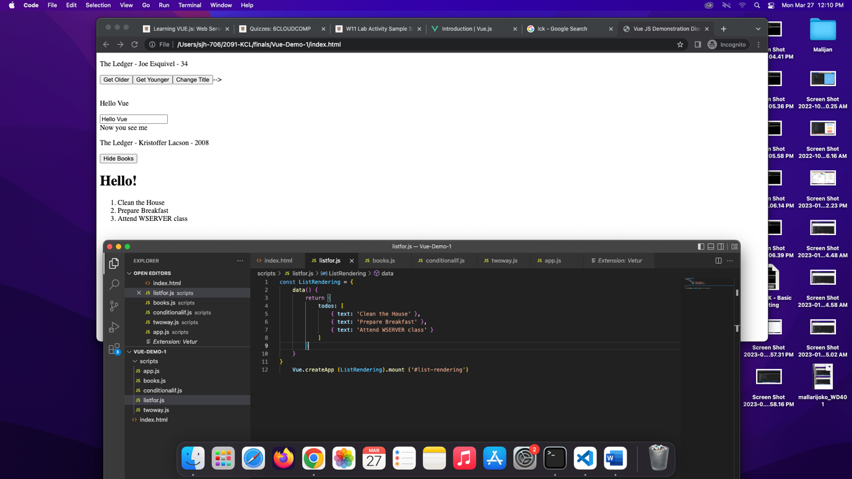

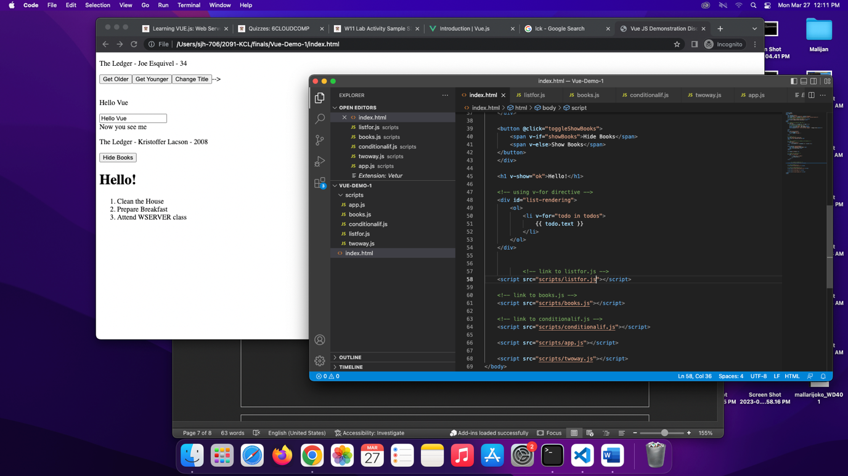

Reflection:

Upon doing the activity, there were some realizations that were encountered. Having some background with HTML and CSS, JavaScript has been quite tough for me. However, it was quite different with Vue.JS. Although the coding itself looks very complex at first glance, it was actually very simple with proper comprehension. As long as there is an attempt understand the construction of the codes, they will be able to digest them. Furthermore, the Vue.js itself allowed me to understand the various programming concepts that I usually struggle with, especially in JavaScript. Moreover, there were several concepts that were integrated in the activity that further expanded my horizon regarding this, and they all applied various directives to function and execute a specific programming task. It was fascinating to see the program execute with no error or issues.